**Sentiment Analysis Project Documentation**

**Overview**

This project aims to develop a sentiment analysis model using deep learning techniques to predict the sentiment (positive or negative) of textual reviews. The model will be trained on a dataset containing labeled reviews and deployed as a web application using Gradio.

**Table of Contents**

1. Introduction

2. Data Collection

3. Data Pre-processing

4. Model Development

5. Model Evaluation

6. Deployment

7. Conclusion

**1. Introduction**

Sentiment analysis, also known as opinion mining, is a natural language processing (NLP) task that involves identifying and classifying subjective information in text data. This project focuses on sentiment analysis of textual reviews, where the goal is to predict whether a review expresses positive or negative sentiment.

**2. Data Collection**

* The dataset is available as name ‘Evaluation-dataset.csv’
* The dataset is loaded in Notebook using pandas methods as follows

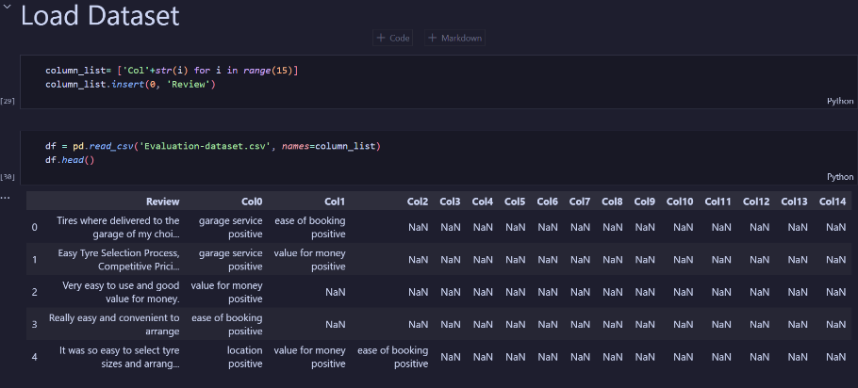

**3. Data Pre-processing**

* Tokenization: Convert text data into tokens (words or subwords).
* Padding: Ensure that all input sequences have the same length.
* Encoding: Convert tokens into numerical representations.
* Splitting: Divide the dataset into training and testing sets.

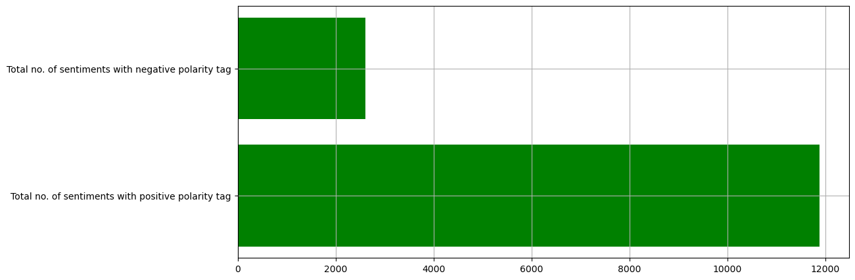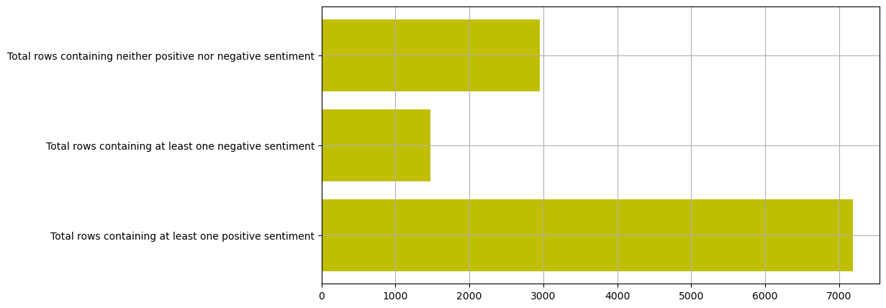

**4. Model Development**

* + Choose a deep learning architecture for sentiment analysis (e.g., LSTM, GRU).
  + 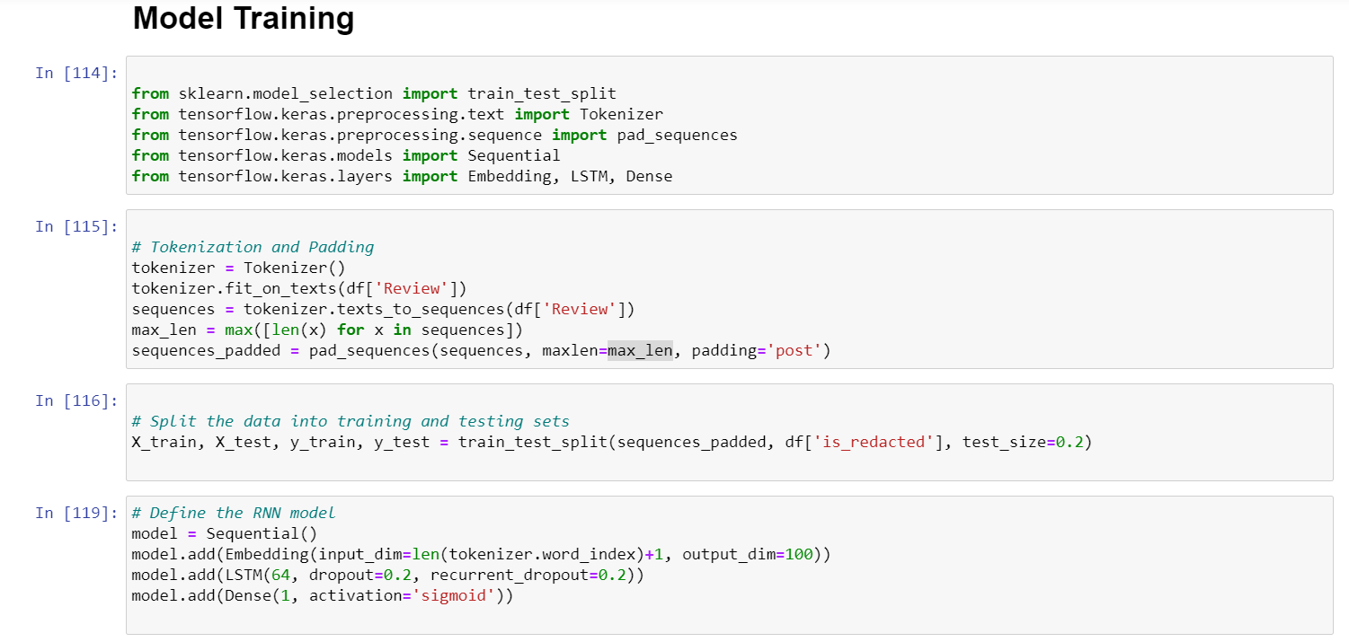Define the model architecture using TensorFlow or Keras.
  + 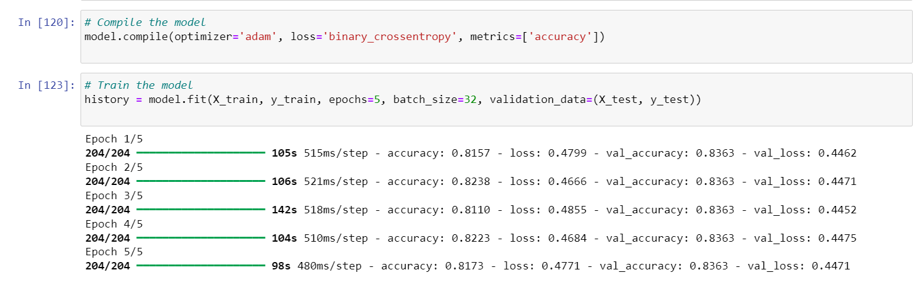Compile the model with appropriate loss function, optimizer, and evaluation metric.
  + Train the model on the training dataset.
  + Fine-tune hyperparameters as needed.

**5. Model Evaluation**

* + Evaluate the trained model on the testing dataset.
  + Measure performance metrics such as accuracy, precision, recall, and F1-score.
  + 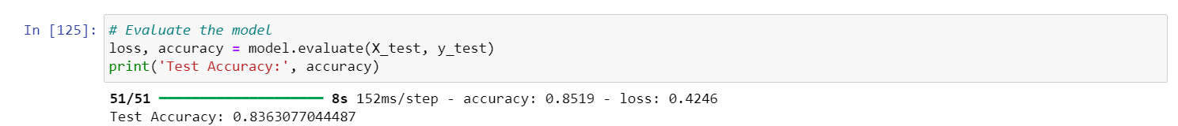Analyze the model's performance and identify areas for improvement.

**6. Deployment**

* + Deploy the sentiment analysis model as a web application using Gradio.
  + 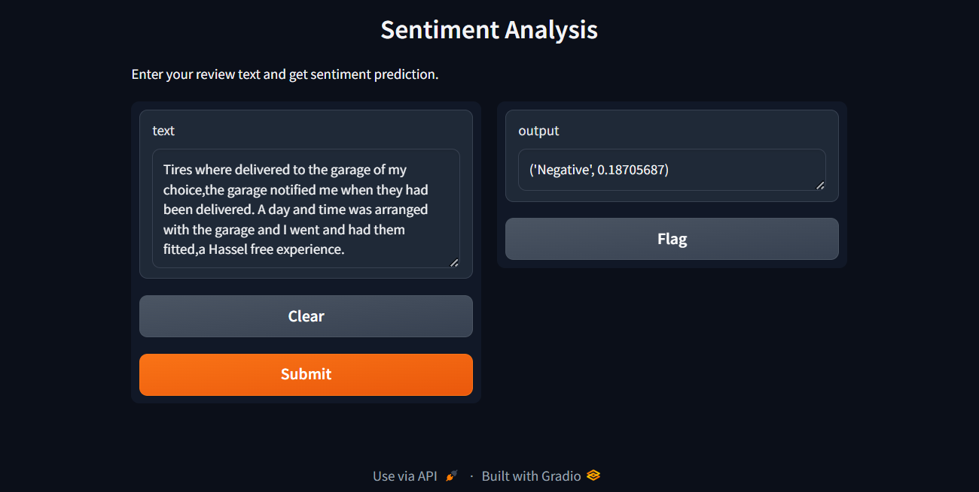Create a user-friendly interface for users to input text and view sentiment predictions.
  + Ensure that the deployed application is scalable, responsive, and easy to use.

**7. Conclusion**

* + Summarize the key findings and outcomes of the project.
  + Also we have training data graph.
  + Reflect on the challenges faced and lessons learned during the development and deployment process.
  + Provide recommendations for future work and improvements.

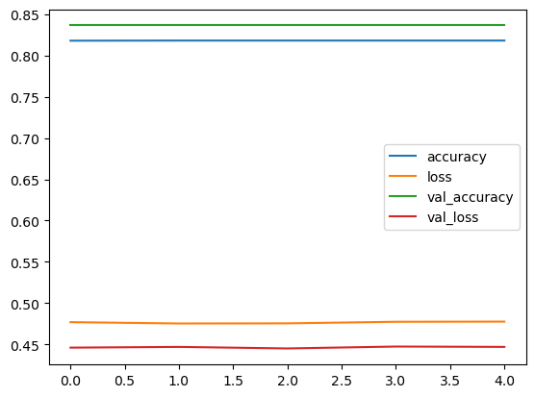

This documentation provides a structured overview of the sentiment analysis project, covering various aspects from data collection to deployment. You can customize and expand this outline based on the specific requirements and scope of your project.